**Project Report Template**

**Title of Project: The** Healthy Plate Project  
**Name of the Innovator:** Pavithra T

**Start Date:** 27-10-2025

**End Date: 31-10-2025**

***Day 1: Empathise & Define***

*Step 1: Understanding the Need*

* Which problem am I trying to solve?

The Healthy Plate Project aims to solve the problem of unhealthy eating habits among children by promoting awareness about balanced diets and the dangers of junk food. It encourages kids to make safer, healthier food choices for better growth and well-being.

* Who is affected by this problem?
* How did I find out about this? [Select whichever is applicable]
* Interviews
* Observation
* Online Research
* AI Tools

*Step 2: What is the problem?*

The problem is that many children eat too much junk food and don’t understand the importance of a balanced diet. This leads to health issues like obesity, low energy, and poor growth..

Why is this problem important to solve?

This problem needs to be solved because unhealthy eating habits in childhood can lead to serious health problems later, such as obesity, diabetes, and heart disease. Teaching children about healthy food early helps them grow stronger and develop lifelong healthy habits.

**Take-home task**

Ask 2-3 people what they think about the project:

* **1.Student (Age 12) :"I think the Healthy Plate Project is really good because it helps us learn which foods are good for our body and which are junk. Now I try to eat more fruits instead of chips!"**
* **2. Parent: "This project is very useful. It encourages children to eat healthy and makes them aware of how junk food can harm their health."**
* **3. Teacher: "I like this idea because it combines learning with healthy habits. It teaches students about nutrition in a fun and creative way."**

*AI Tools you can use for Step 1 and 2:*

**AI Tools Used:**

**🧠 1. ChatGPT**

**Helps collect information about healthy and unhealthy foods.**

**Can write short awareness messages or slogans for posters.**

**Answers questions and gives ideas for your project easily.**

**🎨 2. Canva Magic Studio**

**Uses AI to design attractive posters and infographics.**

**Can automatically suggest layouts, colors, and pictures about healthy food.**

**Helps make your project look creative and professional.**

**3. Pictory AI**

**Turns your text or script into short awareness videos.**

**Adds AI-generated voices and background music.**

**Helps make videos that explain the importance of eating healthy in a fun way**

***Day 2: Ideate***

*Step 3: Brainstorming solutions*

* List **at least 5 different solutions** (wild or realistic):
* **AI Chatbot for The Heathy Plate** – A virtual assistant that educate children about healthy habits in an engaging and interacting way.
* **Skill Learning Website** – A platform to improve knowledge and skills about nutrition
* **Career Awareness Workshops** – explores careers in nutrition, dietetics and heeath educatuon
* **Mobile App for Scholarship Updates** – Sends alerts about junk food and harmful food
* **Community Mentor Program** – Connects students with mentors or professionals from nearby areas for real guidance.
* **The Heathy Plate Project Platform**  – A complete digital platform combining AI guidance, skill modules, and location-based opportunities built using **Meta MGX**, designed to empower rural youth.

*Step 4: My favourite solution:*

*My favorite solution is the AI Chatbot “HealthyBuddy” because it makes learning about healthy eating fun and easy. The chatbot can answer questions, give meal tips, and play food quizzes with children. It helps kids understand the importance of a balanced diet and encourages them to choose healthy foods in an enjoyable way.*

*Step 5: Why am I choosing this solution?*

*I am choosing this solution because the AI Chatbot “HealthyBuddy” is interactive, fun, and easy for children to use. It helps them learn about healthy eating through simple conversations and games, making it more interesting than just reading or watching videos. This way, kids can learn and build good habits while enjoying the process.*

*AI Tools you can use for Step 3-5:*

**AI Tools for Step 3–5**

*AI Tools you can use for Step 1 and 2:*

**AI Tools Used:**

**🧠 1. ChatGPT**

**Helps collect information about healthy and unhealthy foods.**

**Can write short awareness messages or slogans for posters.**

**Answers questions and gives ideas for your project easily.**

**🎨 2. Canva Magic Studio**

**Uses AI to design attractive posters and infographics.**

**Can automatically suggest layouts, colors, and pictures about healthy food.**

**Helps make your project look creative and professional.**

**3. Pictory AI**

**Turns your text or script into short awareness videos.**

**Adds AI-generated voices and background music.**

**Helps make videos that explain the importance of eating healthy in a fun way**

*AI Tools you can use for the take-home task:*

**Canva AI/CoPilot AI/Meta AI:** Use these mobile-based tools to generate images for the solution they want to design

***Day 3: Prototype & Test***

*Step 6: Prototype – Building my first version*

What will my solution look like?

**What My Solution Will Look Like – HealthyBuddy Chatbot 🤖🥗**

**1. A colorful, child-friendly interface with fun food-themed designs.**

**2. A chatbot character (like a smiling fruit or vegetable) that talks with children.**

**3. Kids can ask questions such as “What is a healthy breakfast?” or “Why is junk food bad?”**

**4. The chatbot gives simple answers, pictures, and healthy tips**

**5. Includes mini quizzes and games to make learning fun and interactive.**

**6. Can be used on a mobile phone or computer as a small web or app-based chatbot.Design Style:**

* Simple, intuitive, and easy to navigate for rural youth.
* Bright and engaging visuals to make learning and exploration fun.
* Mobile-friendly layout for easy access on smartphones.

**Prototype Tools:**

* Built using **Meta MGX**, no coding required, with all features **interactive and testable**.

What AI tools will I need to build this?

**AI Tools Needed to Build The Heathy Plate project**

1. **Meta MGX**
   * No-code platform to **design and deploy the app**.
   * Allows building **interactive screens, chat interfaces, and skill modules** without coding.
2. **ChatGPT (or similar LLMs)**
   * To **generate content, conversation flows, and career guidance responses**.
   * Can help **personalize recommendations** for users based on their profile and location.
3. **AI Chatbot Design References**
   * **Google Dialogflow / IBM Watson Assistant / Microsoft Bot Framework**
   * To **structure conversation logic** and handle user queries effectively.
4. **AI Recommendation Tools** *(Optional but useful)*
   * For **matching students with careers, scholarships, and nearby opportunities**.
   * Could use **ML-based ranking algorithms** or **existing AI APIs** for personalization.
5. **AI Data Analysis Tools** *(Optional for insights)*
   * **Python AI libraries (Pandas, Scikit-learn)** or **AI analytics platforms**
   * To analyze user interactions and improve recommendations over time.

What AI tools I finally selected to build this solution?

1. **Chat GPT**
2. **Metamgx**

**< Build The Innovation>**

**<DASHBOAD OF THE TOOL>**

**Tool Link:**  **https://mgx-l7l1u7edw5.mgx.world**

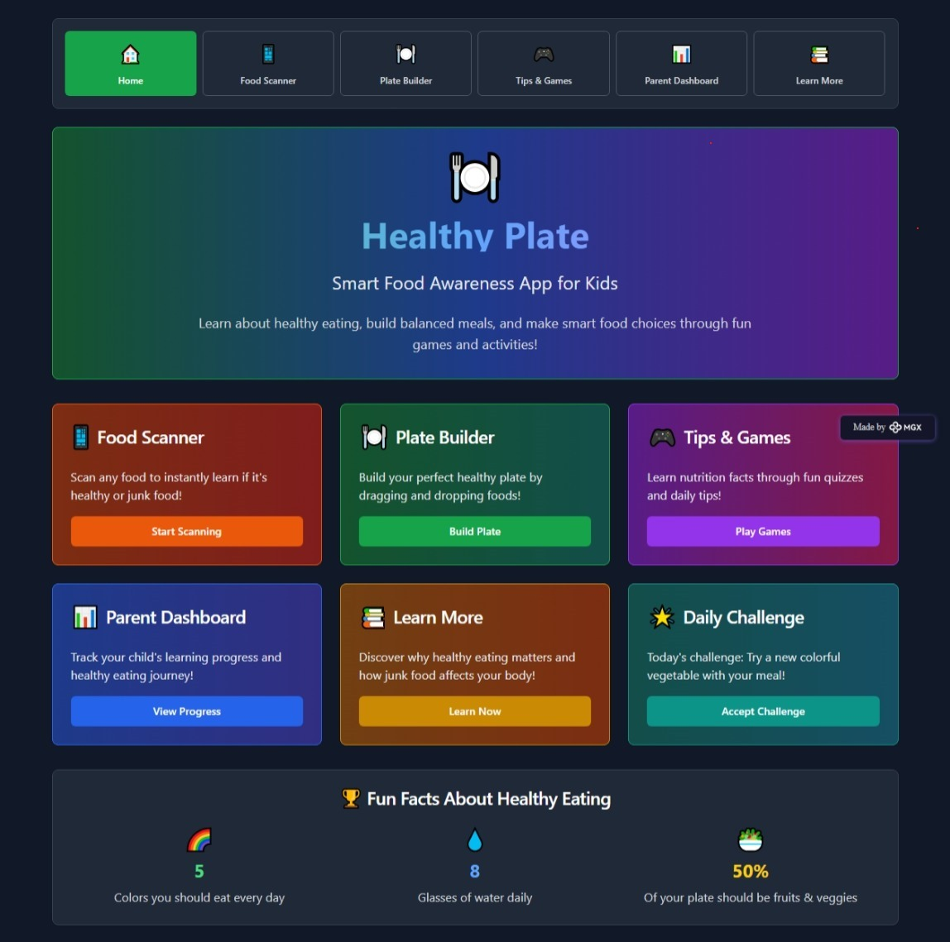

Internal Working of tool:

Profile Creation: 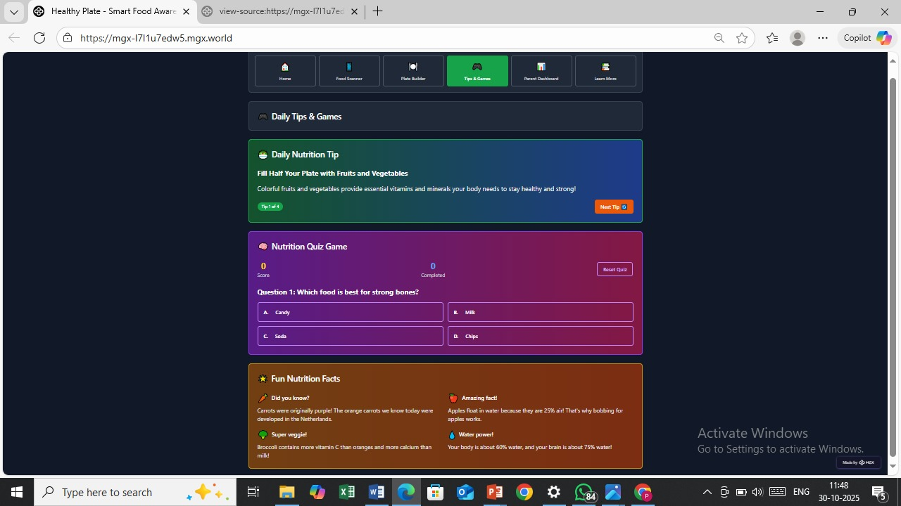

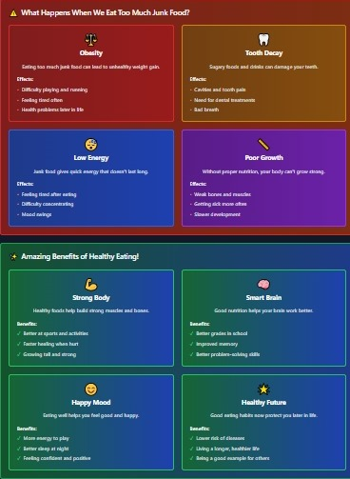

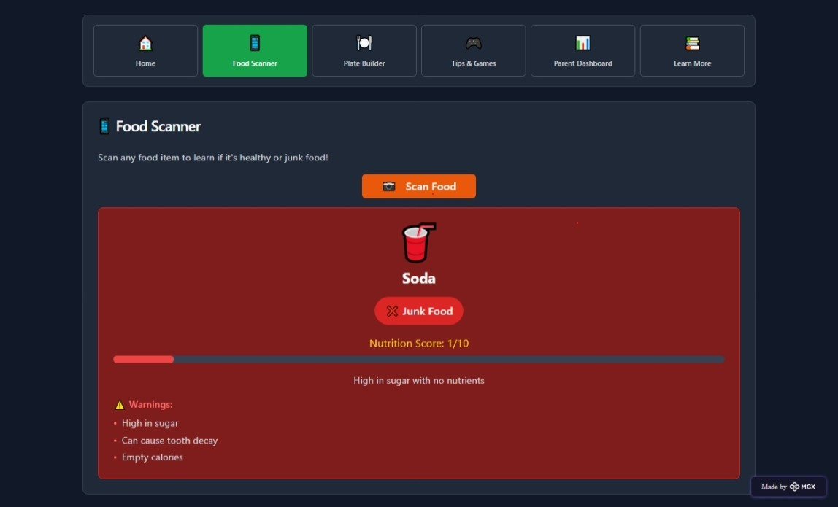



*Step 7: Test – Getting Feedback*

* Who did I share my solution with?

I shared my The Healthy Plate Project solution with:

* **Students from rural areas** – to get feedback on usability and relevance.
* **Teachers and career guidance counselors** – to understand how well it supports career decision-making.
* **Parents of rural students** – to see if it helps families access information about education and jobs.
* **Peers and mentors** – for suggestions on improving features and design.

What feedback did I receive?

**Feedback: Pros and Cons**

**Pros (Positive Insights from Feedback):**

1. Users found the **AI assistant helpful** for exploring career and higher education options.
2. The concept of the platform is **promising** and shows potential for rural youth guidance.
3. Skill modules and location-based suggestions were appreciated as **useful features**.

**Cons (Areas to Improve Noted in Feedback):**

1. Chatbot responses sometimes **repeat options**, which can confuse users.
2. Certain **interactive features are restricted** or not fully accessible in the prototype.
3. Limited resources and integrations mean users can only access a **basic version** of guidance and opportunities.

**My Response for The Feedback:**  
The Healthy Plate Project is an idea created using a **no-code tool (Meta MGX)**. As it’s an initial prototype, the resources and integrations are limited. To fully integrate all features and access a wider range of career, scholarship, and skill-building resources, we would need **collaborations with different platforms and organizations**. The current limitations are due to the constraints of the prototype environment, but the concept demonstrates the **potential, usability, and impact** of the platform for rural youth.

👍 What works well:

**What Works Well**

* **Lifetime Access:** Unlike other tools, Career Path built on Meta MGX **doesn’t require subscriptions** and can be updated or modified anytime.
* **No-Code Development:** Users can **create and maintain the app without coding knowledge**, making it accessible to students and beginners.
* **Personalized Guidance:** AI assistant provides **tailored career, scholarship, and job recommendations**.
* **Skill Building:** Interactive modules help improve **English, aptitude, and soft skills** for better employability.
* **Location-Based Suggestions:** Students can **discover nearby colleges, training centers, and job opportunities** easily.
* **Mobile-Friendly and Intuitive:** Designed for **easy navigation and continuous accessibility**, even in rural areas.

🔧 What needs improvement:

* **Chatbot Responses:** Currently, the AI sometimes **repeats options**, which can confuse users.
* **Interactive Features:** Some features are **restricted or not fully accessible** in the prototype.
* **Resource Integration:** Limited access to career, scholarship, and skill-building resources.
* **Collaborations Needed:** To expand functionality, partnerships with **other platforms and organizations** are required.
* **User Experience Enhancements:** Further improvements in **navigation, visuals, and engagement** could make the app more intuitive and appealing.

*AI Tools you can use for Step 6-7:*

**ChatGPT/Perplexity AI/Claude AI/Canva AI/Chatling AI/Figma AI/Metamgx/Gamma AI**: You can use these tools to build solutions/models or mock-up dummy prototypes

***Day 4: Showcase***

*Step 8: Presenting my Innovation:*I am presenting **CareerPath**, a **digital career guidance and skill development platform** for rural youth. It features:

* An **AI-powered virtual assistant** that provides personalized career, scholarship, and job guidance.
* **Skill development modules** for English, aptitude, and soft skills.
* **Location-based suggestions** for nearby colleges, training centers, and opportunities.
* A **user-friendly, mobile-friendly interface** built on **Meta MGX** with lifetime access and easy updates.

**Impact:** CareerPath helps students make informed decisions, improves employability, and bridges the guidance gap in rural areas.

**<SHOWCASE YOUR INNOVATION TO YOUR PEERS>**

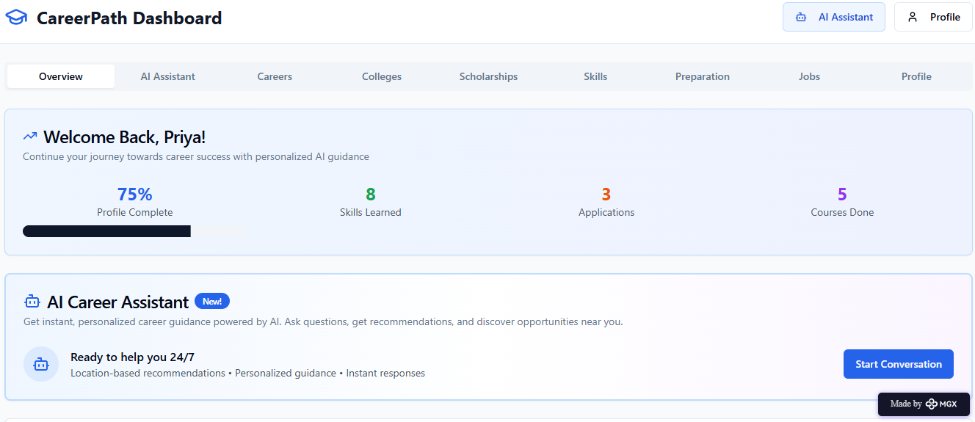

*Step 9: Reflections*

* What did I enjoy the most during this project-based learning activity?

I enjoyed **building CareerPath using a no-code tool** and seeing my idea take a **real, interactive form**. It was exciting to **design the AI assistant, skill modules, and location-based features**, and imagine how it could **empower rural youth** to make better career decisions.

What was my biggest challenge during this project-based learning activity?

My biggest challenge was **integrating all features smoothly** in the prototype using a no-code tool, especially ensuring the **AI assistant, skill modules, and location-based recommendations** worked together effectively with limited resources.

**Take-home task**

<https://github.com/punithhcreator/Careerpath-No-code-application>

*AI Tools you can use for Step 8:*

**Canva AI:** You can use this to design your pitch document. Download your pitch document as a PDF file and upload on GitHub